Project Name |  | Confidentiality Level
DBMS |  | For Recipients’ Reference Only
Project ID | Version | Document Code
BP | 1.0 | Project ID

DBMS Software Requirements Specification



Copyright © Ruankosoft Technologies(Shenzhen), Co., Ltd.
. All Rights Reserved
Revision Record
Date | Revision Version | CR ID /Defect ID | Sec No. | Change Description | Author
Content
1 Introduction 6
1.1 Purpose 6
1.2 Scope 6
2 General description 6
2.1 Software perspective 6
2.1.1 About the Project 6
2.1.2 Environment of Product 6
2.2 Software function 6
2.3 Actors 6
2.4 User characteristics 6
2.5 Assumptions & Dependencies 7
2.6 System Use Case 7
2.7 Sub-module Functional Requirements 1 7
2.7.1 Functional Requirements1 7
2.7.2 Functional Requirements2 8
2.8 Sub-module Functional Requirements2 9
2.8.1 Functional Requirements1 9
2.8.2 Functional Requirements2 9
2.9 Data Information 9
3 Interface Requirements 9
3.1 User Interface 9
3.2 Software Interface 10
4 Overall Design Constraints 10
4.1 Hardware Limitations 10
4.2 Technology Limitations 10
5 Software Quality Attributes 10
6 Requirements Classification 10

Introduction

Purpose

This manual describes user requirements for function and performance of the Database Management System. The intended audience includes: Users, Project administrators, Testers, Designers, Developers

The manual focuses on function requirements of DBMS; clarifies mandatory functions, performance and interface of the developed software; assists system analysts and software developers in user demand-orientation.

Scope
The manual analyzes the logical model of the DBMS from users’ perspective. It answers the question “What does the system do?” by listing functions and services provided to client. The manual omits development skills, but describes user requirements through demand analysis and model establishment. It is a common ground for game users, developers and other participants to communicate.

General description

Software perspective

About the Project

Database Management System is large-scale software which can manipulate and manage the database. It is used establish, use and maintain the database, and called DBMS for short. It manages and controls the database in a unified manner to ensure the security and integrity of the database. The user accesses the databases through DBMS. It can make many applications and users establish, modify and query the database through different method at the same time or different moments. Most DBMS provided DDL (Data Definition Language) and DML (Data Manipulation Language) for users to define the schema structure and permission constraint of the database, and implement the data operation: add, delete, etc.

Environment of Product
This system is a Window desktop window program. It stores the data with the file system of the operating system. It can implement the communication between the client and server through the network.

Software function
The functional structure diagram is as follows:
DBMS

Database Maintenance

Security Management

Database Management
Table Management

Field Management

Transaction Management

Index Management

Client Management

Data Management

Integrity Management

Create Databases
Drop Database
Create Table
Alter Table
Drop Table
Add Field
Alter Field
Drop Field
Insert record
Select record
Update record
Delete record

User characteristics
The user of this system are the database administrators and the client users.
The database administrator requires some database management knowledge, and can install, deploy, create, manage and maintain the database.
The client use requires some application operation knowledge, and can use this database to implement the function of data storage, modification, query, etc.

Assumptions & Dependencies
This system generally uses the WINDOWS operating system, if users have additional operational requirements under the particular circumstance, the system should have a portable condition.

Specific Requirements

System Use Case
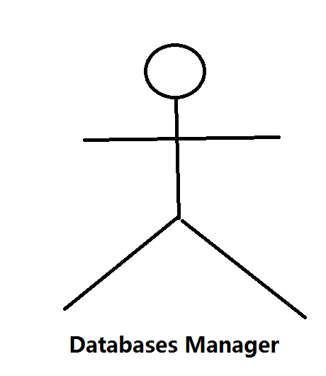
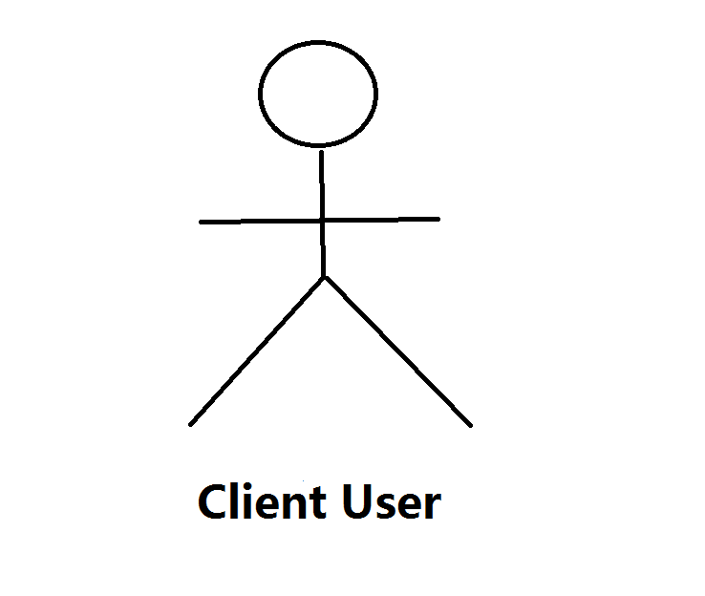
Table Management
Field Management
Data Management
Index Management
Client Management
Database Management

Transaction Management

Integrity Management

Database Maintenance

Security Management

Database Management
1.Sub-module introduction
Create and delete the database. Implement database definition file creation, modification and query.
Create Database
2. Sub-module use case diagram
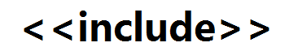
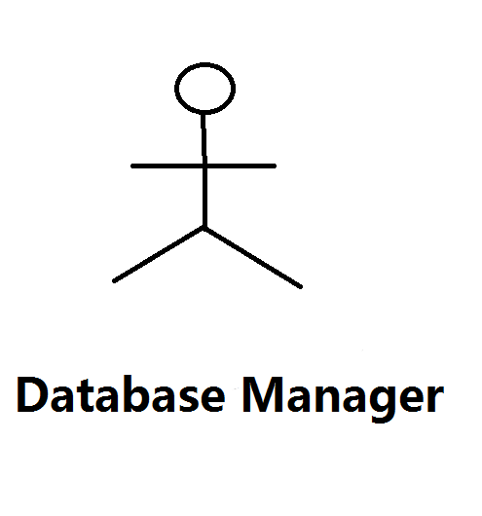
Database Management
Drop Database

3.2.1 Create Database
1. Introduction
Implement the function of database creation SQL statement: CREATE DATABASE<database name>. The database is divided into two types: user database and system database. The system database is database Ruanko created by the system when the system is created. This database can’t be deleted.
2. Inputs
Database name, database date file storage path, database creation time, database type.
3. Process
(1)determine the validity of the database name.
The length of the database name can’t exceed 128 characters. If the name is too long, the database can’t be created and prompt the user.
(2)save the database information into database file ruanko.db.
Determine whether ruanko.db file exists under the system directory. If it exists, append to the file. If it doesn’t exist, create ruanko.db file.

4. Output
Create or update database description file ruanko.db file, add or delete the database information.

3.2.2Drop Database
1. Introduction
Implement the function of database deletion. Corresponding SQL statement: DROP DATABASE <database name>. the database is divided into two types: the user database and system database.
2. Inputs
The database name, database data file storage path, database creation time, database type.
3. Process
- Determine whether the database exists.
- Determine whether the database is used by the user. If there is a user that connects to it, it can not be deleted.
- Delete the database information from ruanko.db file.
- Delete all files related to the database.
4. Output
Delete the database description file in database description file ruanko.db.

Table management

3.4.1 Create Table
1. Introduction
Implement database table creation function. Corresponding SQL statement: CREATE TABLE <table name>. when the table is created, add the basic information of the table into the table information file of the current database. The table description file is :[Database Name].tb.
2. Inputs
Database name, table name, table definition file path, table integrity file path, table record file path, table index file path, table creation time, last modification time(is creation time),table field count (initial is 0), total number of records in table(initial is 0).
3. Process
- Determine the validity of the table name.
- Get the paths of four table definition files according to the rule.
- Save the table information to table description file”[Database Name].tb” file. If the table information file does not exist, create the file. If it exist, append the record to the end of the file.
4. Output
Create or update the table description file: “[Database Name].tb”.

3.4.2 Alter Table
1. Introduction
2. Inputs
Database name, table name, table definition file path, table integrity file path, table record file path, table index file path, table creation time, last modification time (is current time),table field count, total number of records in table.
3. Output
Update table description file:”[Database Name].tb”

Data management

Insert Record

Update Record

Select record

Delete Record

Index management

Establish the index for the key field in the database. In the data operation, optimize the query with the index.

Client management

Implement the client-server structure. The client can connect to main servers. The server can provide service for many clients.

Transaction management

Implement transaction management function in the database.

Integrity management

Implement transaction management function in the database.

Database management

Implement the functions of database integrity constraint check and management.

Database management

Implement the functions of database backup and recovery.

Security management

Implement user management, permission management

Data information

Data Type
System data type | Description | Size | Program data type
INTEGER | Integer | 4byte | int
BOOL | Boolean type | 1byte | bool
DOUBLE | Float type | 2tyte | Double
VARCHAR(n) | String type, maximum length is 255, ended with “\0” to mark the end of a string. | (n+1)byte | Char[n+1]
DATETIME | Data time type | 16byte | SYSTEMTIME

Integrit
    - database file
Type | File | Name | Remark
Data definition file | Database description file | ruanko.db | Save the database information
Data definition file | Table description file | *.tb | Save the field information
Data definition file | Table definition file | *.tdf | Save the integrity constriants
Data definition file | Integrity description file | *.tic | Save the definition of the index
Data definition file | Index description file | *.tid
Data file | Record file | *.trd
Data file | Index data file | *.ix
Data file | Log file | *.log

Interface Requirements

User Interface
For most users, screens are larger than 17 inches, the resolution is 1024X768，and software interface should adapt to the screen dimension.

Software Interface
This is a windows application program with GUI.

Hardware Limitations

Minimum configuration on a computer:

CPU:1 GHZ
Memory :128 MB

Technology Limitations

File format: binary mode file format.

Coding standerd:c++ coding standerd

Software Quality Attributes

Reliability

Adaptability: new service and functions can be easily added to the system on the basis of its basic function, without affecting the architecture of the original website system. The system can adapt to browsers of multiple versions.

Fault tolerance
Recorverability

Usability

The interface design should be reasonable, concentrating system functions and making the system user-friend. The system should block user’s illegal input data or operations, provide wizards and notes for complex processing, and users with handy help information.

Requirements Classification

Requirement ID | Requirement Name | Classification
3.2.1 | Create databases | A
3.2.2 | Drop databases | C
3.3.1 | Create table | A
3.3.2 | Alter table | C
3.3.3 | Drop table | C
3.4.1 | Add field | A
3.4.2 | Alter field | C
3.4.3 | Drop field | B
3.5.1 | Insert record | A
3.5.2 | Update record | B
3.5.3 | Select record | A
3.5.4 | Delete record | C
3.6 | Index management | A
3.7 | Client management | B
3.8 | Transaction management | C
3. 9 | Integrity management | B
3.10 | Database maintenance | C
3.11 | Security management | C

Importance of requirements is classified as following:
- Mandatory: absolutely essential features, without which the product development will be canceled.
- Important: unessential features that may affect the viability of the product.
- Nice to have L desired features, the absence of which will not affect the product viability.

